Palette and Brush

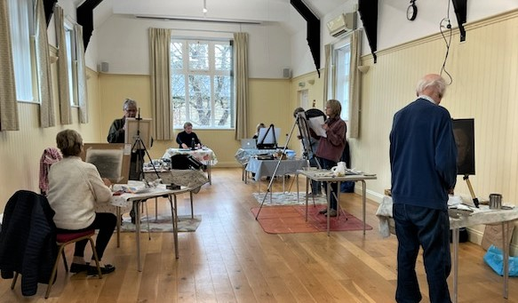

A group of artists specialising in Oil painting with tuition.
Open to all. No previous experience in oil painting necessary.
If you are interested in joining contact Chirria Hutchison at chirria.hutchison@gmail.com

